Key Stage 1 Lunches
The Kids Lunch Company. Ltd is a local independent business that has been providing healthy lunches into local primary schools for 21 years.
The cold lunch choices are displayed in willow baskets on gingham tablecloths and the children help themselves to a buffet style lunch. We provide a choice of several different sandwich fillings on a variety of breads and rolls. Each sandwich has a fun sticker on denoting the filling making it quick and easy for your child to identify which sandwiches they like to eat.
There is a variety of yoghurts, cheese, fruit and vegetables & savoury snacks available each day, and cakes / treats are provided on a Friday. Each child is given a tray and chooses what they would like from the table.
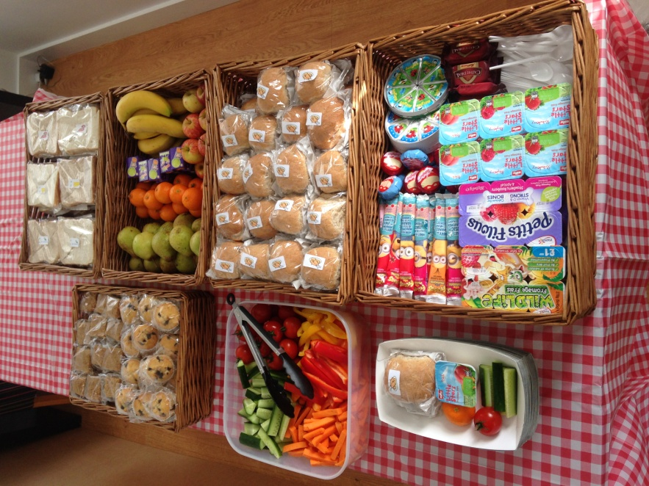

For specific food intolerances or allergies or for children who prefer a without butter sandwich please complete the specific diet request form. Please hand this into school or call or email us. Your child’s sandwich will be clearly labelled with their name.
Please don’t hesitate to contact us with any queries or concerns, we understand that little children can worry about food & will do all we can to help.
Call us on: 01628 475941 or email us at: kitchen@kidslunch.co.uk

